

PRESENTATION BY:

SUSAN NAEEM Student id: 1645302
SYEDA ALIZA NAQVI Student id: 1643608
YAMNA MOHIUDDIN Student id: 1644485
MANSI KUMARI Student id: 1644487
LALITA KUMARI Student id: 1644483

Index of the Project Presentation
- Introduction
  - Overview of the project
  - Purpose and objectives
- Project Workflow
  - Step-by-step process of how the system works
- Technology Stack
  - Programming languages, frameworks, and tools used
- Code Structure & Implementation
  - Explanation of key files (index.html, etc.)
  - Screenshot of important code snippets
- Website UI & Screenshots
  - Homepage etc.
- Flowchart & Diagrams
  - System architecture & data flow
- Challenges & Solutions
  - Issues faced during development & how they were resolved
- Future Enhancements
  - Possible improvements & next steps
- Conclusion
  - Summary & final thoughts

INTRODUCTION
Universal Stationary is a web-based stationery store designed to offer a convenient and user-friendly shopping experience for students, professionals, and office workers. The platform provides a wide variety of school and office supplies, including pencils, tumblers, erasers, paints, paint brushes, sharpeners, bags, and rulers.
This project is developed as part of a web development course to demonstrate the implementation of front-end technologies like HTML, CSS, Bootstrap, and JavaScript. The website includes key features like:
- A responsive homepage with a category-based navigation menu.
- Search functionality to help users find items easily.
- Dedicated category pages for each type of stationery item.
- An About Us section to introduce the brand and its mission.
- A Contact Us page with integrated Google Maps and company details.
- A Feedback form that allows users to rate their experience and provide suggestions.
The goal of the project is to simulate a real-world e-commerce platform with a clean UI and practical navigation system, making it easier for users to browse and purchase stationery items.

2. Proposed Solution
The primary objective of this project is to address the need for a centralized, user-friendly platform where customers can easily browse and purchase a wide variety of stationery and office supplies. Traditional stationery shopping can be time-consuming and limited by physical availability. To overcome these challenges, we propose a web-based solution — Universal Stationary.

✅ Key Elements of the Proposed Solution:
- Responsive Web Interface
The website is designed using HTML, CSS, and Bootstrap to ensure responsiveness across all devices including desktops, tablets, and smartphones.
- Categorized Product Display
All products are neatly organized into relevant categories such as pencils, erasers, tumblers, paint brushes, bags, and more. This helps users find items quickly and efficiently.
- Search Functionality
A built-in search bar allows users to directly search for specific items without browsing through every category.
- Feedback System
Users can rate their experience and provide written feedback. This feature allows the business to gather valuable insights for continuous improvement.
- Informative Pages
  - About Us: Gives users a clear understanding of the brand, its mission, and its values.
Contact Us: Provides physical address, email, phone number, and an embedded map to locate the store easily.
- Attractive User Experience (UX)
The interface uses clean colors, card-based layouts, and organized menus to offer an intuitive and pleasant shopping experience.

Purpose of Documentation
The purpose of this documentation is to provide a comprehensive overview of the Universal Stationary website project. It serves as a guide for understanding the structure, design, and functionality of the website, as well as the development process behind it.

Problem Statement
In today’s fast-paced world, students, office workers, and artists often face difficulties in finding a reliable and easy-to-navigate online platform that offers a wide variety of stationery products. Physical stores may have limited options, and many online shopping websites are cluttered or lack proper categorization, making it time-consuming and frustrating for users to find exactly what they need.
Moreover, beginners or casual buyers may find it challenging to get detailed information about stationery items or compare products easily before making a purchase decision.
The Universal Stationary website aims to solve these problems by providing a simple, organized, and user-friendly online platform where users can explore different categories of stationery products. This website will help users quickly access relevant products, learn about their features, and make informed choices, all in one place.

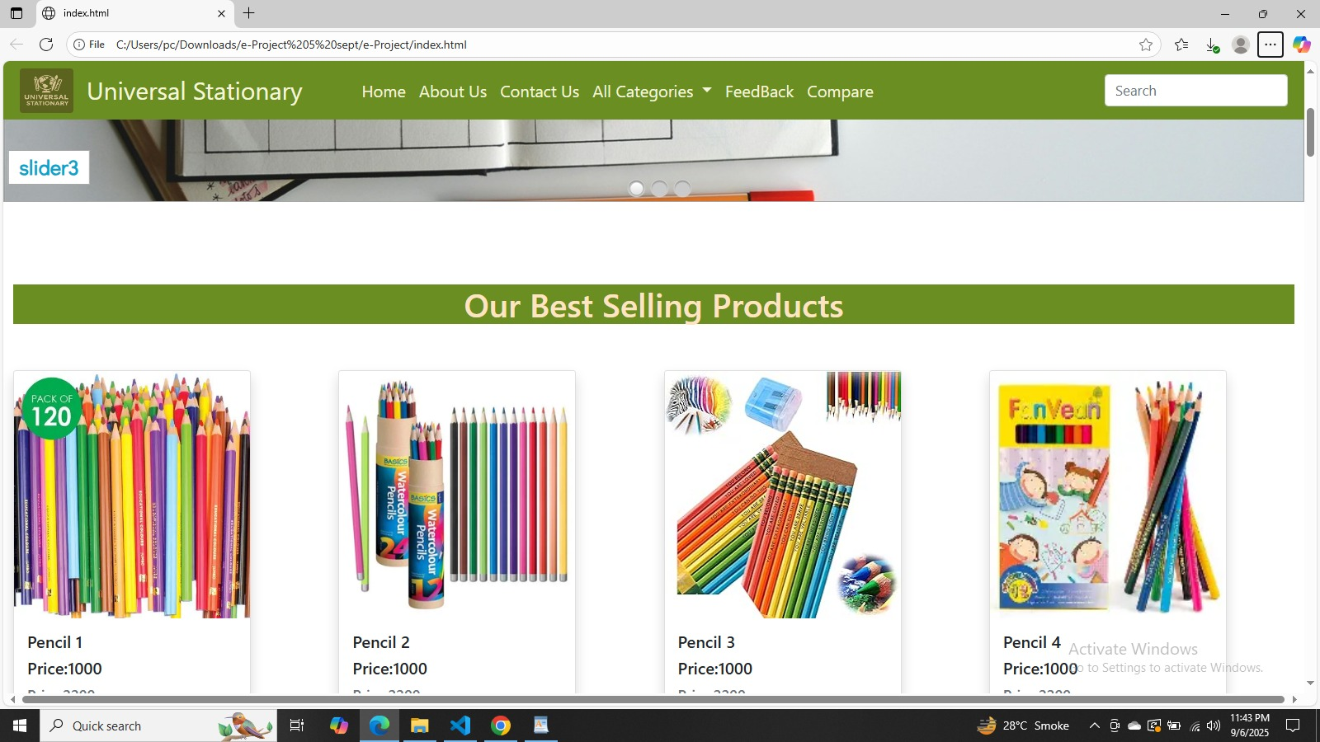
Home Page:
The Universal Stationary Website is designed to provide users with an easy-to-navigate online platform for browsing and purchasing stationary items. The page shown is the Home Page, which highlights the best-selling products and includes navigation features for exploring categories, comparing products, and submitting fee

Future Enhancements
- Add shopping cart and checkout system.
- Add user login/registration system.
- Implement product filters (by price, brand, rating).
- Add customer reviews under each product.
- Make the design fully mobile responsive

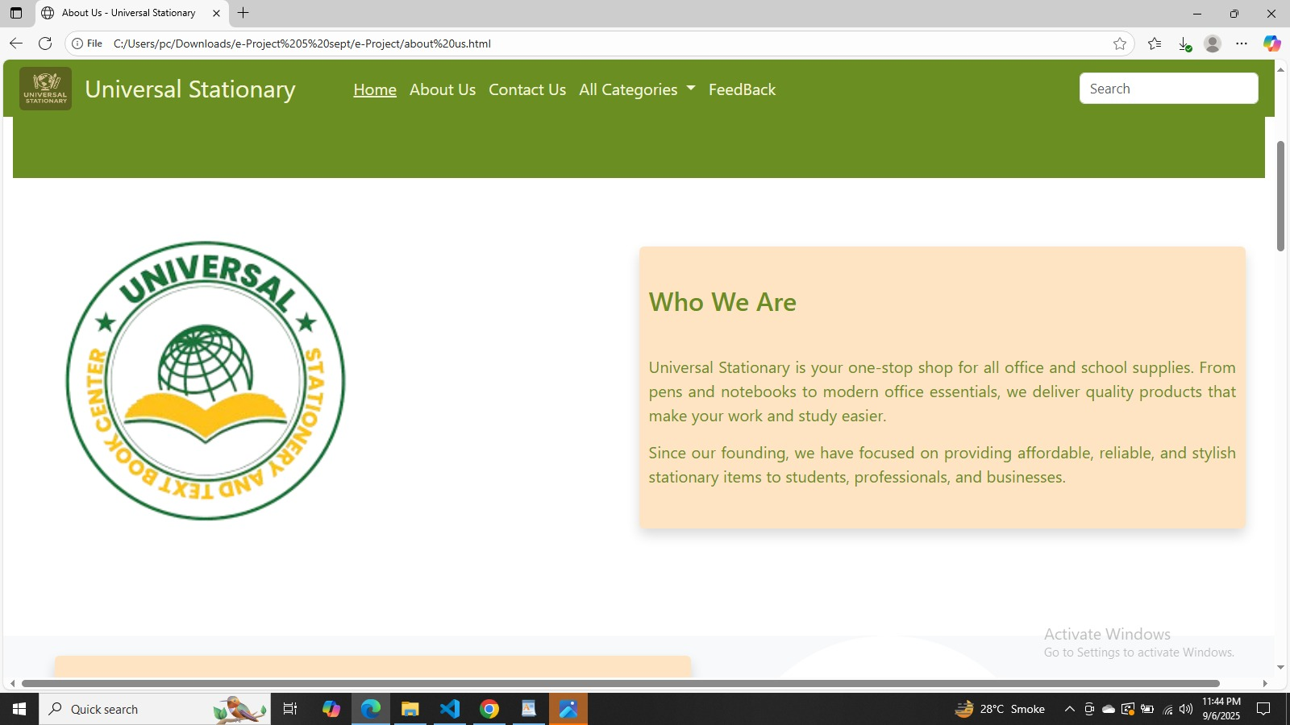

About us Page
The About Us page provides visitors with an overview of Universal Stationary. It explains the mission, vision, and purpose of the business while building trust with customers. This page highlights the company’s focus on delivering quality, affordable, and reliable stationary products for different types of users.

Importance of This Page
- Builds credibility by introducing the company.
- Helps users understand the brand identity.
- Provides a clear idea of the products and services offered.
- Creates a professional impression with a clean layout.

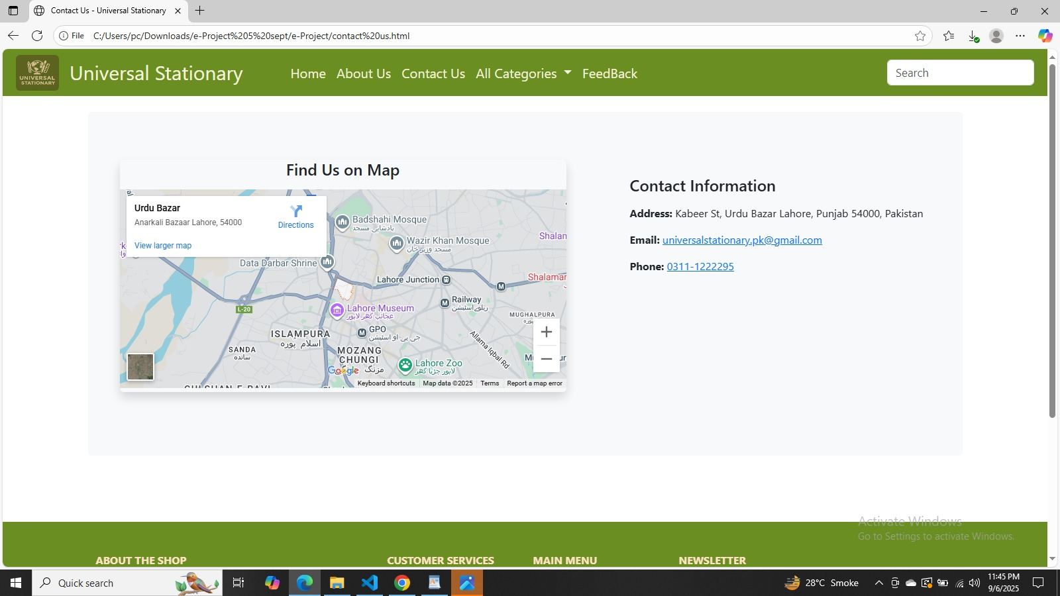
Contact Page:
The Contact Us Page of Universal Stationary allows customers to connect with the company directly. It provides essential contact details such as the address, email, and phone number, along with a live Google Map integration for easy location tracking. This page builds trust by offering multiple ways to reach the business.

Importance of the Page
- Builds trust by showing real business details.
- Makes it easy to reach the company online or offline.
- Improves customer support and engagement.
- Strengthens the brand with a professional, informative design.
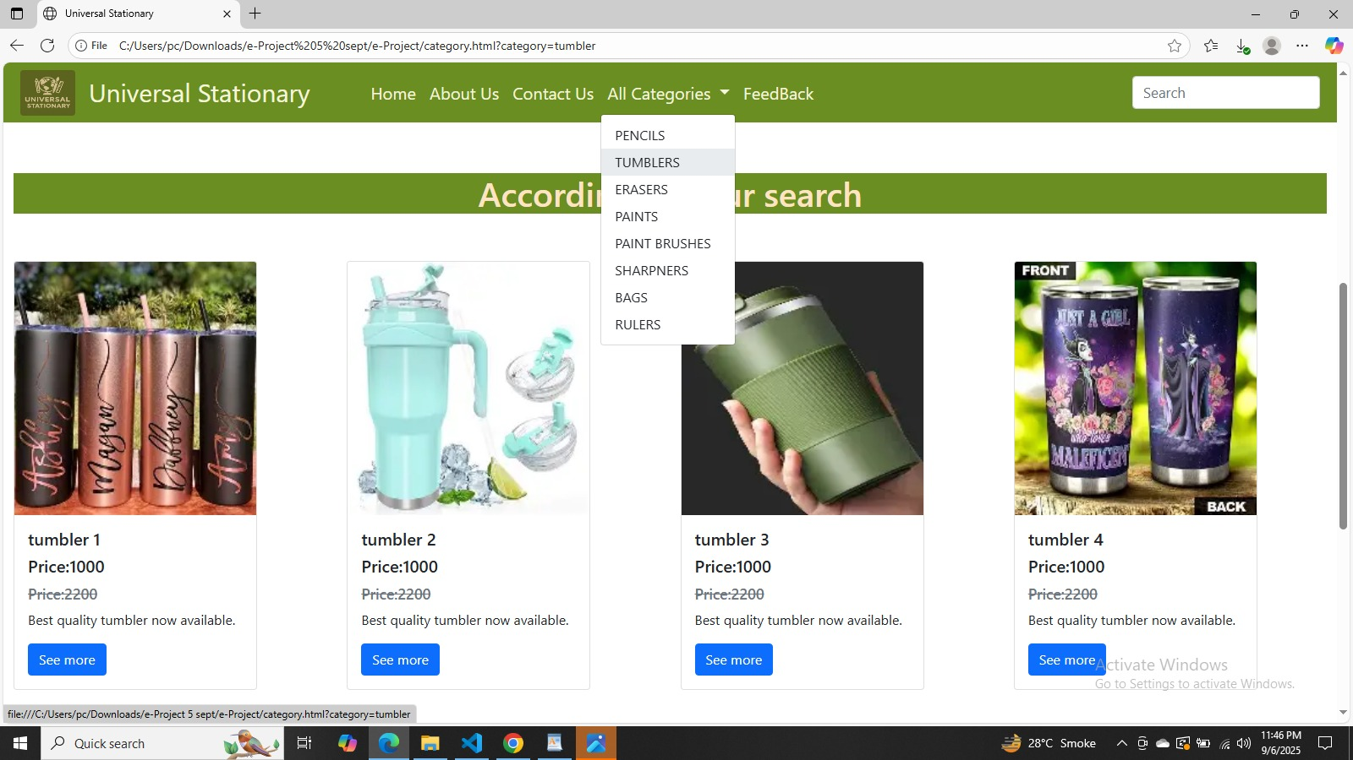
Categories Page:
- The Categories Page of Universal Stationary is designed to help customers quickly explore products by type. Instead of browsing through all products, users can directly access their desired category, making shopping easier, faster, and more organized.

Importance of Categories Page
- Helps customers find products quickly and efficiently.
- Improves navigation by grouping items logically.
- Provides a professional shopping experience similar to e-commerce stores.
- Highlights the range of products Universal Stationary offer.

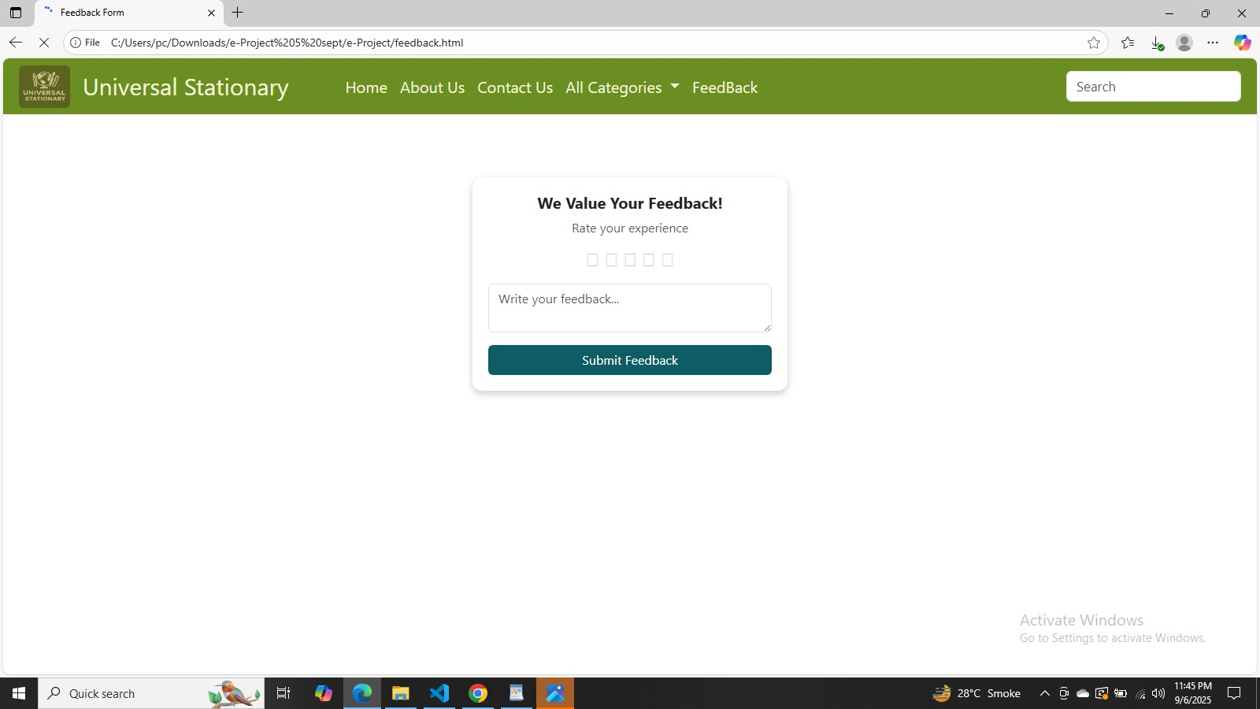
Feedback Page:
The Feedback Page of Universal Stationary allows users to share their experiences and rate the services/products. It contains a star rating system and a text feedback box where customers can provide detailed suggestions. This page helps the business improve quality and customer satisfaction.

Importance of the Page
- Improves customer engagement by letting them share opinions.
- Helps the company identify strengths and weaknesses.
- Provides quantitative (stars) and qualitative (text) feedback.
- Builds trust by showing that customer satisfaction matters.

Flowchart

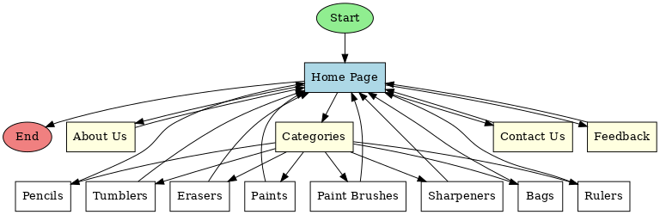

CODE STRUCTURE & IMPLEMENTATION:

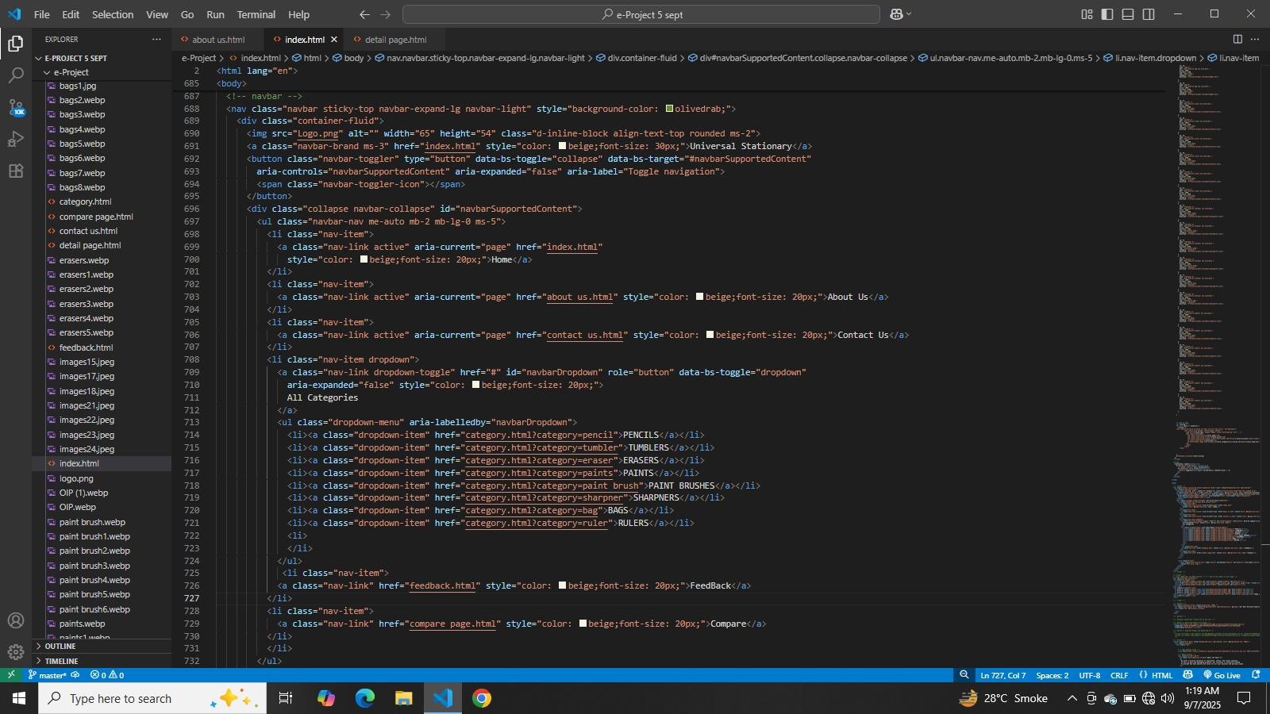
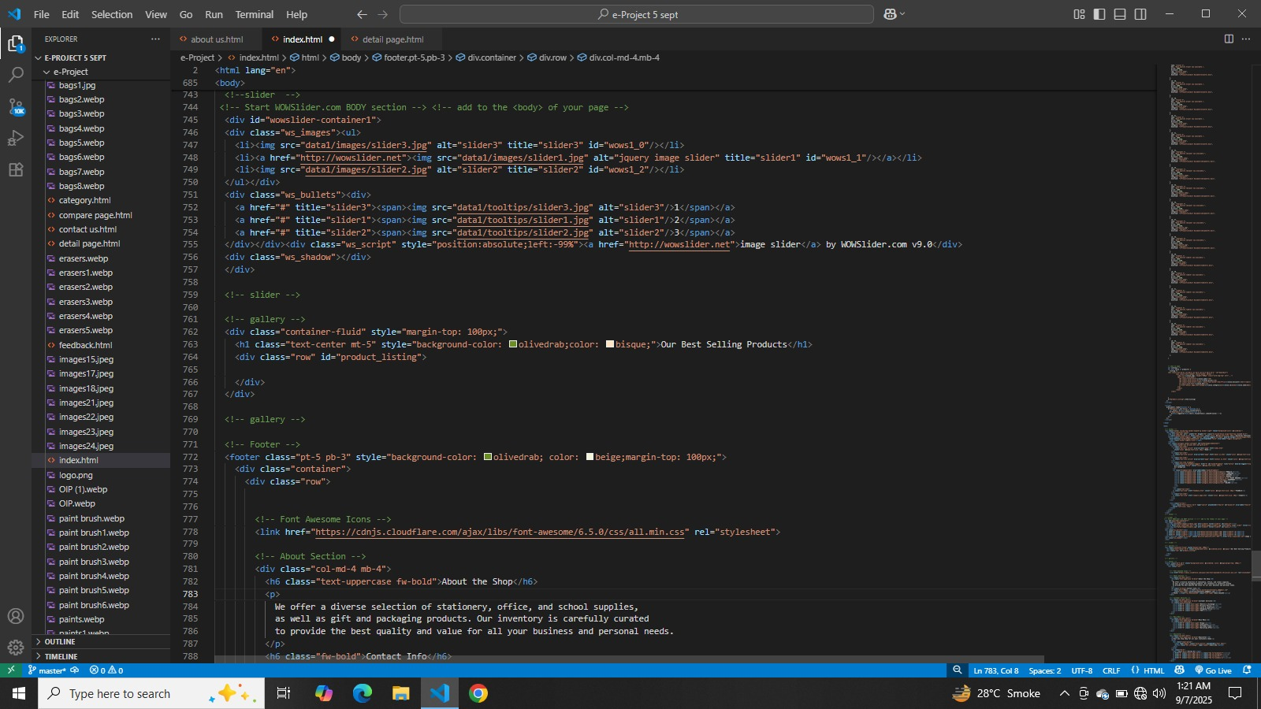

CONCLUSION:

Summary
The Universal Stationary Website is designed as a complete online platform for providing quality stationery and office supplies. The project includes multiple pages with unique purposes:
- Home Page → Gives an introduction and quick access to all sections.
- About Us Page → Explains the company’s mission, vision, and dedication to affordable and reliable products.
- Categories Page → Displays different product types like pencils, tumblers, erasers, paints, brushes, sharpeners, bags, and rulers with brief descriptions.
- Contact Us Page → Provides communication channels for customer support and inquiries.
- Feedback Page → Collects customer reviews with a star rating and written suggestions to improve products and services.
Each page contributes to a professional, user-friendly, and responsive website that ensures easy navigation and customer engagement.

Final Thought
The Universal Stationary Website reflects how technology can simplify shopping for everyday needs like stationery. By focusing on clarity, accessibility, and customer satisfaction, the site sets a foundation for future growth.
With further improvements—such as online purchasing, secure payment integration, and customer accounts—this website can evolve into a complete e-commerce solution.
Ultimately, the project highlights that a well-structured, user-friendly website builds trust, attracts customers, and strengthens business reputation.

